**Sao Tome and Principe country profile**

Published

14 May 2018

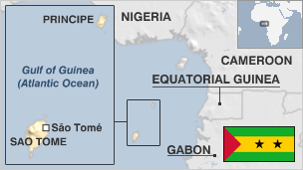

**Sao Tome and Principe, once a leading cocoa producer, consists of two islands of volcanic origin and a number of smaller islets lying off the coast of Africa.**

From the late 1400s Portugal began settling convicts on Sao Tome and establishing sugar plantations with the help of slaves from the mainland. The island was also important in the transshipment of slaves.

The colony's aspirations for independence were recognised after the 1974 coup in Portugal and at first the Movement for the Liberation of Sao Tome and Principe was the country's sole political party. However, the 1990 constitution created a multi-party democracy.

The island of Principe assumed autonomy in 1995.

The country hopes to reduce its dependence on donors and cocoa exports by exploiting offshore oil.

* Read more [country profiles](http://news.bbc.co.uk/1/hi/country_profiles/) - Profiles by [BBC Monitoring](http://bbc.co.uk/monitoring)

**President: Evaristo Carvalho**

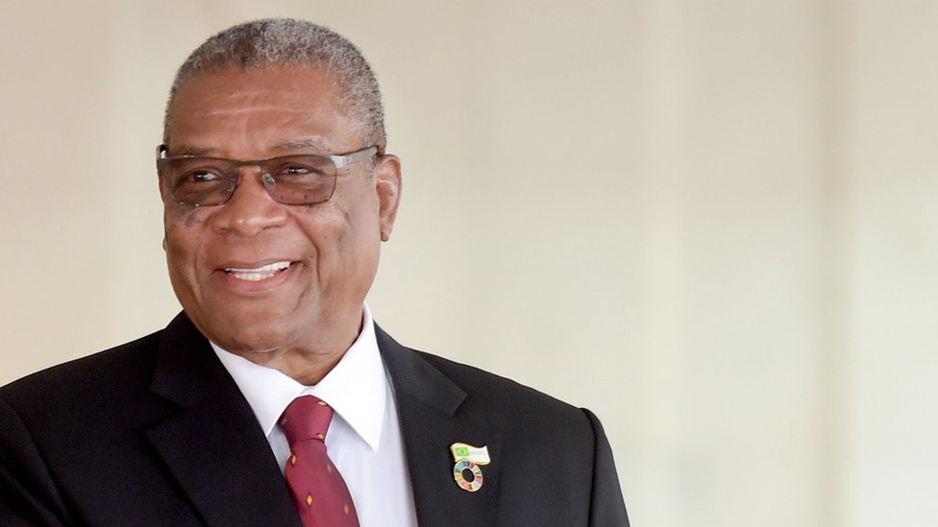image copyrightGetty Images

Evaristo Carvalho - a former prime minister - won the run-off presidential election in August 2016.

Vice president of the ruling ADI party, Mr Carvalho was guaranteed victory in the run-off after his rival, incumbent President Pinto da Costa, dropped out alleging irregularities in the first round.

Mr Carvalho, 75 at the time of being elected, was prime minister in 1994 and again in 2001-2002, and has also served as president of the national assembly and defence minister.

Sao Tome has a tradition of premiers and presidents from opposing camps governing together peacefully. Now, however, both top jobs are held by the ADI party.

The president has an arbitrating role in government but no executive powers, leaving the prime minister in the dominant position.

**Prime minister: Patrice Emery Trovoada**

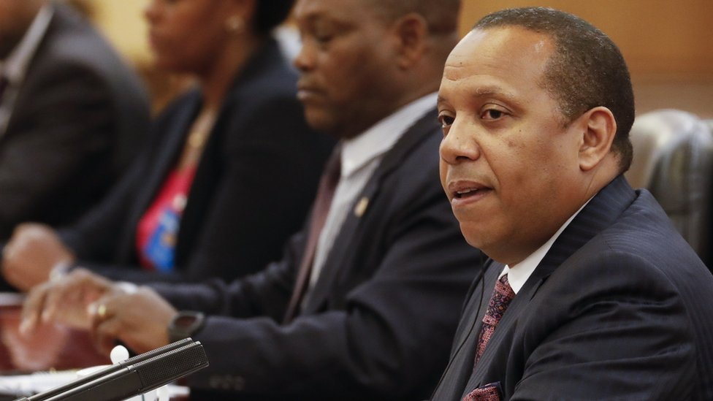image copyrightGetty Images

Patrice Emery Trovoada was appointed prime minister by President Manuel Pinto da Costa in 2014 following elections which his Independent Democratic Action (ADI) party won.

Mr Trovoada first served as prime minister in 2008 by his government fell after a vote of no confidence. He began a second term as prime minister in August 2010, and was again unseated following a vote of no-confidence in December 2012. He is the son of former President Miguel Trovoada.

Freedom of expression, guaranteed by the constitution, is also respected in practice.

The state runs the only radio and TV stations but no law forbids private broadcasting.

# Sao Tome and Principe profile

Published

14 May 2018

**A chronology of key events:**

**16th century** - Sao Tome colonised by the Portuguese, who bring in slaves to work sugar plantations. Becomes important staging post for slave trade.

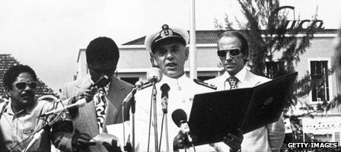image copyrightGetty Images

image captionPortugal granted independence in 1975

**1800s** - Cocoa introduced. Sao Tome develops into one of world's main cocoa producers.

**1951** - Becomes overseas province of Portugal.

**1960** - Formation of nationalist group which later becomes the socialist oriented Movement for the Liberation of Sao Tome and Principe (MLSTP).

**1974** - Military coup in Portugal. Portuguese government recognises islands' right to independence, acknowledges MLSTP as sole representative in negotiations. Unrest followed by exodus of Portuguese.

## Independence

**1975** 12 July - Independence, with Manuel Pinto da Costa (MLSTP) as president; and Miguel Trovoada as prime minister. Plantations nationalised, strong ties built up with communist countries.

**1978** - Government announces suppression of coup attempt, brings in Angolan troops for support.

**1979** - Trovoada arrested, accused of complicity in coup attempt. He is released and goes into exile in 1981.

**1980s** - Government scales down links with communist world as economy deteriorates. Declares itself nonaligned, seeks Western support for recovery plans.

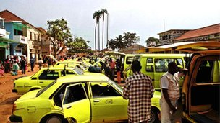image copyrightGetty Images

image captionSao Tome is a major producer of cocao

**1988** - Coup attempt.

**1990** - New constitution allows opposition parties, provides for multi-party elections and restricts president to two five-year terms. Trovoada returns from exile.

## Multiparty elections

**1991** - First multiparty elections. Renamed MLSTP-PSD loses majority. Transitional government installed, pending presidential elections, subsequently won by independent candidate Trovoada.

**1992** - Popular unrest sparked by austerity measures.

**1994** - MLSTP-PSD regains power. Parliament grants Principe local autonomy.

**1995** - Trovoada toppled and detained in bloodless coup by soldiers but is reinstated within days after pressure from donor countries.

**1996** - Trovoada re-elected president. Popular protests over economic hardships.

**1997** - Unrest over economic conditions.

Sao Tome establishes formal diplomatic relations with Taiwan at Trovoada's behest. The move is condemned by the government. China retaliates by suspending ties.

**1998** - MLSTP-PSD wins general elections, Guilherme Posser da Costa appointed prime minister.

**2000** - Civil servants strike to press for higher pay. Officials say country's external debt in 1998 amounted to US $270 million, more than five times the country's annual gross domestic product of around US $50 million.

## De Menezes sworn in

**2001** - Businessman Fradique de Menezes is declared the winner in the presidential election in July and is sworn into office in early September.

**2002** March - MLSTP narrowly wins parliamentary elections. De Menezes appoints Gabriel Costa as prime minister and both main political parties agree to form broad-based government.

**2002** August - President De Menezes announces plans for a US naval base in the country, which would aim to protect Sao Tome's oil interests.

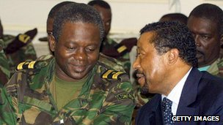image copyrightGetty Images

image captionLeaders of the 2003 coup were given amnesty for reinstating the president

**2002** October - President De Menezes names new government with Maria das Neves as premier. It replaces administration led by former prime minister Gabriel Costa, which was dismissed by De Menezes in September.

**2003** 16 July - Military coup topples the government. President De Menezes, in Nigeria at the time, returns to Sao Tome a week later after an agreement is struck with the junta. A general amnesty is given to the coup leaders.

## Coup attempt

**2003** October - Oil companies bid for offshore oil blocs controlled by Sao Tome and Nigeria. Bids are expected to generate hundreds of millions of dollars in licence money for Sao Tome.

**2004** March - Row between president, prime minister over control of oil deals threatens to topple government. Four cabinet ministers are replaced.

**2004** September - President De Menezes sacks the prime minister and government after a series of corruption scandals. A new prime minister is sworn in.

**2004** December - Parliament approves oil law designed to protect revenues from corruption.

**2005** February - Sao Tome - jointly with Nigeria - signs its first offshore oil exploration and production-sharing agreement with international oil firms.

**2005** June - Prime minister and government resign. Head of the central bank Maria do Carmo Silveira becomes the new premier.

**2006** March - Protests against poor living conditions disrupt parliamentary elections in some constituencies, delaying announcement of results. The president's Democratic Movement of Forces for Change (MDFM) is declared winner, taking 23 of the 55 seats in parliament.

## Debt waived

**2007** March - World Bank, IMF forgive $360 million in debt owed by Sao Tome. This represents about 90% of the country's foreign debt.

Nigeria and Sao Tome agree to establish a joint military commission to protect their common oil interests in the Gulf of Guinea.

**2008** February - Opposition leader Patrice Trovoada becomes prime minister, but is dismissed in May after a no-confidence vote.

**2008** June - Rafael Branco, head of Sao Tome's second largest party, sworn in as prime minister at head of a new governing coalition.

**2008** December - Several high-ranking former government officials, including to ex-prime ministers, appear in court in Sao Tome's largest corruption scandal.

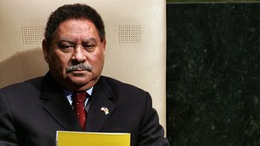image copyrightGetty Images

image captionFradique de Menezes served as president for a decade

**2009** February - Government says coup plot foiled.

**2009** December - Nigeria and Sao Tome agree to set up a joint maritime military commission to protect offshore crude oil fields.

**2010** January - Opposition leader Arlecio Costa, jailed over February 2009 coup plot, is pardoned.

**2010** March - Sao Tome opens tenders for oil exploitation.

**2010** August - Opposition Independent Democratic Action (ADI) party wins parliamentary elections. Patrice Trovoada becomes premier.

**2011** August - Independence-era leader Manuel Pinto da Costa wins presidential election.

**2012** December - President Pinto da Costa dismisses Prime Minister Patrice Trovoada following a no-confidence vote in the national assembly.

**2014** October - Opposition ADI party wins parliamentary elections with an outright majority.

**2016** August - Evaristo Carvalho becomes president following elections.

**2016** December - Sao Tome re-established diplomatic relations with China after cutting ties with Taiwan.